STANDARD OPERATING PROCEDURE FOR FLUORESCENT ACTIN QUANTIFICATION IN IMAGEJ

# 1. SUMMARY

This SOP describes how to use the ImageJ1 macro FActin_v2.ijm to automatically quantify fluorescence intensity and relative Actin concentration. This method is based off the equations/relationship of Actin concentration and intensity found in Sébastien Schaub et al.2

# 2. SOFTWARE and CODES

* ImageJ
  + ThresholdSelection_Mean.ijm
  + DataTable.ijm
  + FActin_v3.ijm
* Excel Template: “FActin Template”

# 

# 3. METHODS

## 3.1- ImageJ Picture Set-Up and Running the Macro

Before beginning, make sure each image to be counted has the same keyword (optional) in the same folder.

# Go to Process >> Batch >> Macro… and a Menu will pop up. Input the following parameters and click process

* Input: Location of folder with selected images
* Filename contains: key word of photos you want analyzed. If blank, the macro will run on all photos in selected folder
* Open…: locate and select ThresholdSelection_Mean.ijm

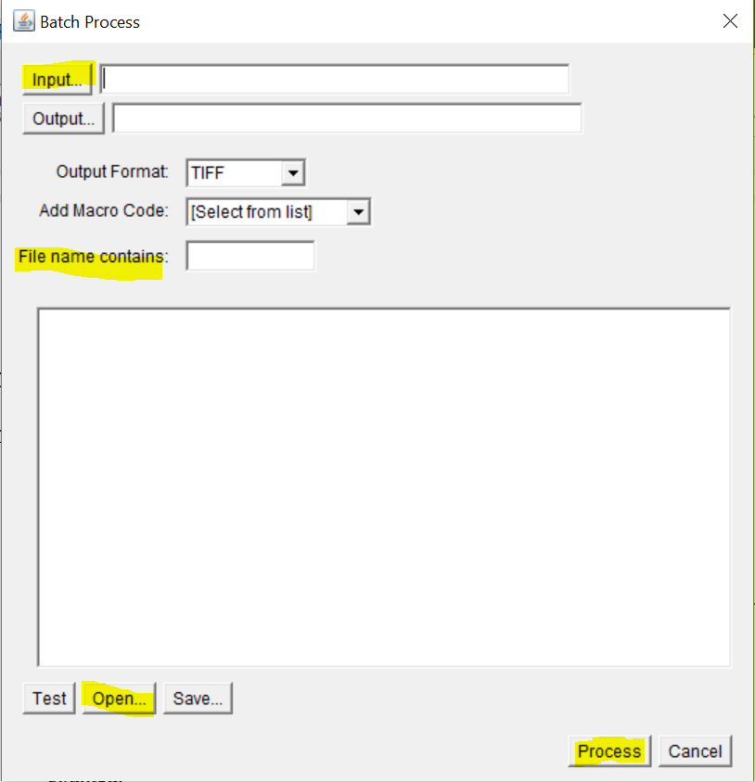

# Once done running, copy the Mean thresholds from the “Log” window and average the values to find a good lower bound to be used later. You may want to run this separately on different groups if they were measured at different times/under different circumstances/parameters.

# Use the ‘Straight’ tool and draw a line along the scale.

# Go to Analyze >> Set Scale. This dialog box will show up. Change the ‘Known distance’ to the scale size (in this case to 100). In ‘Unit of Length’ input um. Check the box for ‘Global’ and then click ‘OK.’

## 3.2 – Creating the Data Table

1. Go to Plugins >> Macros >> Run… and select the file “DataTable.ijm” where it is stored. A Data Table like below should be made:

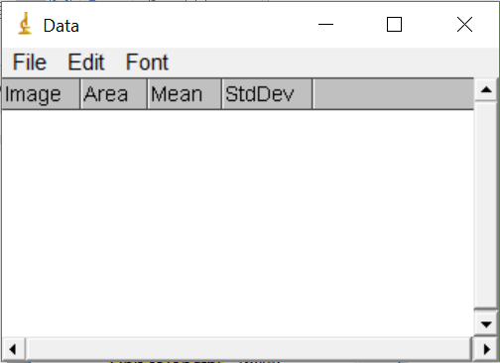

## 3.3 - Running Batch Counting IHC

# Go to Process >> Batch >> Macro… and a Menu will pop up. Input the following parameters and click process

* Input: Location of folder with selected images
* Filename contains: key word of photos you want analyzed. If blank, the macro will run on all photos in selected folder
* Open…: locate and select *FActin_v3.ijm*



# Organize Results and Calculate in Excel.

## 3.4 - Calculation Actin Concentration from Image Intensity

1. Open FActin Template.xls Excel sheet
2. Insert Data from Results in the ImageJ program into the input area on the excel template

NOTE: from the paper we get…

$$Contrast= \frac{s.d. }{Mean Intensity}$$

$$\frac{\left[Actin\right]}{Cell*Area}=\frac{1}{{Contrast}^{2}}$$

**To calculate relative actin use:**

$$\frac{\left[Actin\right]}{Cell}=\frac{Area* {Mean Intensity}^{2}}{{S.D.}^{2}}$$

# HIGH-LEVEL FActin.ijm MACRO DESCRIPTION

1. Split RGB image into Red, Blue, and Green Channels. Run a Rolling Ball Algorithm for background correction of images
   1. (Radius = 800 pixels, may need to adjust depending on cell area ultimately counted; radius = radius of largest object not in background)
2. Use Minimum Threshold to select scale bar and remove from all channels
3. Locate Nuclei and split image by cells identified
4. Select Actin Area
5. Split Actin Area by cells identified
6. Move Area selection to Green Channel that will be Analyzed
7. Return: Area, Mean Intensity, S.D., Integrated Density, and RAW Integrated Density

# B. FUTURE ADDITIONS

None Planned

# 4. REFERENCES

1. ImageJ image analysis software. [http://rsb.info.nih.gov/ij/]
2. Sébastien Schaub, Jean-Jacques Meister, Alexander B. Verkhovsky. Journal of Cell Science 2007 120: 1491-1500; doi: 10.1242/jcs.03379